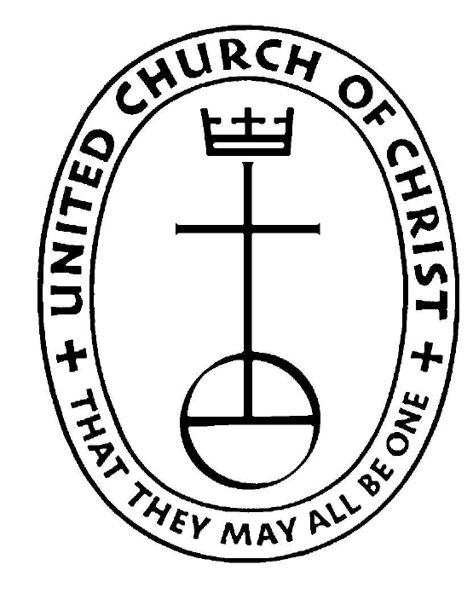 South Newbury Union Church
A United Church of Christ

June 26, 2022 9:30 a.m.
Reflection "Happiness is not a matter of intensity but of balance and order and rhythm and harmony."
- Thomas Merton.
[*=Please stand]

Welcome, Announcements, and Celebrations
Opening Song #63 Give to Our God Immortal Praise v1
[Lighting of Candles]

Call to Worship
One: God gave us family to care for us
All: Lord, help us to take care of those that love us
One: God gave us friends to support us
All: Lord, help us to not forget those who help us
One: God gave us the earth to live and thrive
All: Lord, help us to take care of the gifts you have given us.
*Hymn #72 Great is Thy Faithfulness

*Opening Prayer
We pray to you, Lord, to help us see the truth through the turmoils. Help us to Love each other and not take anything or anyone for granted. Helps us through our hard times and help us not to forget during the good times.

We Worship God with our offerings
*Doxology
*Prayer of Dedication

Scriptures:
Psalm 16
2 Kings 2:1-7,9-14

Time with our Children
[Children may go to Sunday School]
Sermon: Glass breaks but rubber bounces
*Hymn #66 To God Be the Glory

Prayers of the Community (please use microphone so all can hear)
Anyone here is welcome to offer a brief prayer. As you close your prayer, say
“Gracious God”
The community will affirm your prayer by saying,
“Hear our prayer.”
The Lord’s prayer
Our Father, who art in heaven, hallowed be thy name. Thy kingdom come. Thy will be done on earth as it is in heaven. Give us this day our daily bread. And forgive us our debts as we forgive our debtors. And lead us not into temptation, but deliver us from evil. For thine is the kingdom, and the power, and the glory, forever. Amen.

*Hymn #712 Sent Forth By God’s Blessing

*Benediction
*Closing Song #711 verse 1
[extinguish candles and walk out flame]
Savior, again to your dear name we raise
With one accord our parting hymn of praise;
We give you thanks before our worship cease,
And now departing, wait your word of peace
*Moment of Silence
[instrumental “Amen”]

Postlude

Welcome to the South Newbury Union Church! We are glad you chose to worship with us today. This church is an Open and Affirming Congregation of the United Church of Christ.

Prayers and Concerns

Members of our military, their families, and the victims of war/Our sister church in Zimbabwe, the Ivene church in Gweru/Our church, which is our church Family/Pam and Bobby Derderian/Pam and Francis Chambers/Wayne LaPorte/John Wallace/Chris Nichols/Alex Tanksley/Beverly Barker/Bobby Snair/Tim White/Lynn Wallace/Rachael Wallace

Upcoming Events

June 26th- Annual Meeting
July 4th-10am Parade
July 10th – Service is at the Center Meeting House
July 30th - Famous Chicken BBQ
August 20th- 9-2, 32nd Annual Summer Fair Looking for vendors, raffle prizes, fleas and help. See Christine Hill

- If you are visiting with us, please sign our guest book on the table in the back of the church. We appreciate receiving your address and your email address.
- Following Children’s time, children may leave worship to participate in Sunday School at the Friendship House.
- You’ll find a rest room in the Friendship House, just across the parking lot.
- Our Website is www.southnewburyunionchurch.org On the site, you will find information about upcoming events, past sermons, photo galleries, and other useful information.

The South Newbury Union Church
Gathered for Worship
Sunday, June 26, 2022

No matter who you are or where you are on life’s journey, you are welcome here!

Pat Oakes, Lay Preacher
Connie Beal, Musical Director
Elyce Reny, Liturgist

